Georgia State Parks and Historic Sites
Weekly Summary
08.25.2020

Crowds:
As the summer heat continues to impact day-use visitation, this is the second week that no site has had to temporarily limit day use access due to capacity. Social Distancing in day-use and on trails is still needing to be encouraged at several parks, including Cloudland Canyon.

Staffing issues:
The Division has 22 part-time and full-time staff out due to COVID-19 related reasons. 91 employees have been tested for COVID-19, 13 positives, 72 negatives, and 6 awaiting results. Sites are still struggling with housekeeping vacancies, the turnover rate of cottages while fulfilling the extensive cleaning procedures for COVID-19. Laura S. Walker is short staffed in housekeeping and two hosts, making it a challenge to keep the comfort stations clean. Vogel has had 20 cottage turnovers on two consecutive weekends. Managers, Assistant Managers as well as Park Staff in many other positions throughout the state are pitching in to off-set the shortages.
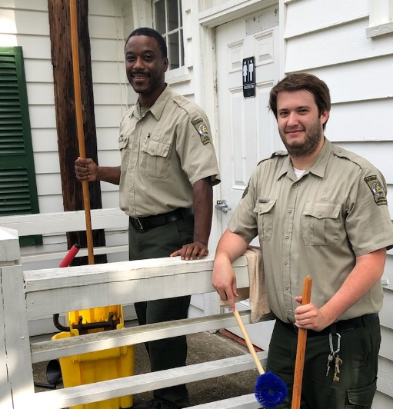

Positives:
- A number of Parks and Historic Sites were recognized through Nominations and Awards at the annual Park and Historic Site Manager’s Conference last week.

- The reservation pageviews continue to be high, up 69% this week over last year. Total pageviews was also high with over 1.1 million pageviews on the website this week. The Alerts page had 4,290 views.

- Fitt.co ran an article on camping near Atlanta that included 4 state parks. https://fitt.co/atlanta/articles/camping-near-atlanta

- Black Rock Park Manager met with Foxfire staff to begin partnering on cultural and natural resource management. Steps are being made to begin Monday self-guided tours at both BRMSP and Foxfire as well as developing Screen Free Saturdays to encourage families to spend time together in the outdoors and learning as opposed to screen time all the time.

- Chief Vann House just received a new Kubota Z411 mower and is putting it to good use.

- The Dahlonega Gold Museum’s visitation is improving and this weekend the Museum filled to capacity and had a delayed entry for a few visitors.

- LE Division presence at Elijah Clark was strong on Saturday, due to an unlicensed boat racing that was took place on the lake (primarily on the SC side). Their presence was very much appreciated by park staff.
- The GIS unit worked on a boundary line issue at High Falls. Larry Atkinson traversed a dense stand of bamboo to find a pivotal boundary monument. A Volunteer assisted the Resource Management Unit with continued hardwood vegetation control at AH Stephens. Approximately (17) acres of thick vegetation has been treated by hand.

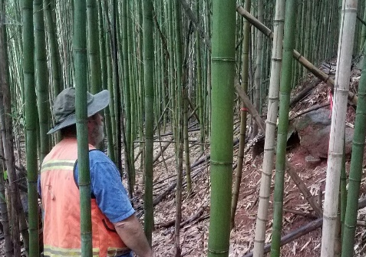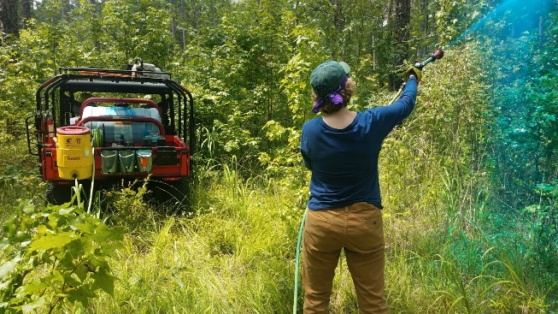

- Ft. McAllister’s office reached capacity several times this past weekend and had to limit entry.

- General Coffee has several newborn goats which are doing well. The park has also added several chicks and two young turkeys on the farm. The park had a guest from out of state with a medical emergency. Park Staff we able to make necessary accommodations with the campsite and facilitate their stay.

- Following the park’s name change, Staff at Jack Hill have started the process to change the park’s entrance sign. Staff also took GPS coordinates and pictures of all road signs in the area to have those changed to Jack Hill State Park as well.

- Week two of the alligator hunt at Reed Bingham began August 23rd. Reed Bingham State Park is proud to be recognized in Georgia Trend’s “Cook County: Community in Motion”

- All currently contracted repairs with IFACS for the Reynolds Mansion have been completed this week. This includes newly painted globes in the circus room and many repairs to the leaded glass front doors which look amazing now and are fully functional.

- LE was on site at Tallulah Gorge this weekend for minor rescues/ walk-outs on stairs that were resolved before park staff could respond.

- Tugaloo and Victoria Bryant swore in multiple Junior Rangers this past week.

- Laura S. Walker purchased additional life jackets for boat rentals to accommodate use and cleaning guidelines. A recent Facebook post featuring Laura S. Walker State Park reached over 31,000 people and had over 3,400 engagements.

- Smithgall Woods has had a busy August in the cottages and day use, including a wedding this weekend that generated $7,500.

- Stephen Foster is working with DNR, DOT, and USDA to address a beaver that has been blocking up drainage alongside HWY 177 into the park. Water has been getting into a phone box and causing phone line issues.

- Park staff at Sweetwater Creek and RMU worked with USDA’s Wildlife Services on tools and techniques to manage geese populations at Sweetwater Creek including this remote-control boat and pyrotechnic launcher.

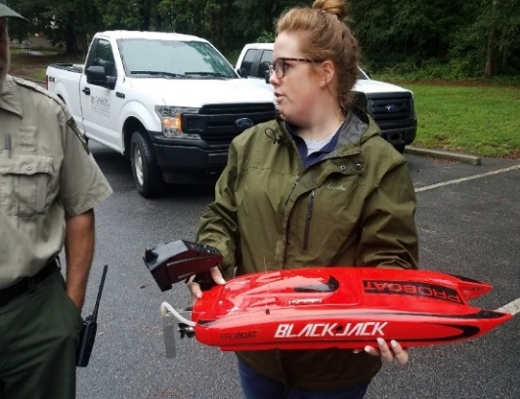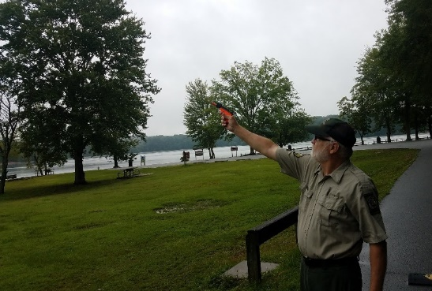

Challenges

- Black Rock lost power for most of Sunday morning which made cleaning 7 cottage turnovers difficult.

- The Park Office at Chattahoochee Bend flooded from a water supply line to the staff restroom. Staff and Friends members removed all retail items, fixtures, counters and countertops. Servpro has removed all the flooring to damaged areas and the park is in the process of drying out the subfloor. Staff are still able to assist Park Visitors with a side door entrance.

- Managing traffic from Hwy. 136, the park entrance, gated entrances and enforcing social distancing in day-use, on trails and around the park at Cloudland Canyon has been a challenge.

- LE Division and local law enforcement assisted park staff at Elijah Clark with a large group noise complaint on Friday evening. On Saturday night, local law enforcement, EMS and park staff responded to a golf cart accident. The guest injured from the accident was taken to a local hospital.

- Fort McAllister suffered water issues throughout the week due to pressure regulation and pipe breaks. Water has been restored to all areas of the park.

- A lightning storm on Tuesday night at Seminole created quite a bit of electrical damage including the phone lines (repaired), washing machine in the linen barn (repaired), HVAC system in the linen barn (in progress of repair), and the fuel level controller (in progress of repair).

Financial Update:

Past Weekend:
Once again overall occupancy for all reservables increased this past weekend by 7% to 63%. All overnight accommodation occupancy improved. Camping continues to see a significant increase, improving 10% to 72% occupancy. Cottage occupancy also had a substantial improvement this past weekend, increasing 11% to 85%. This is the 4th weekend in a row cottage occupancy has risen. Yurt occupancy increased 3% to 94% occupancy.

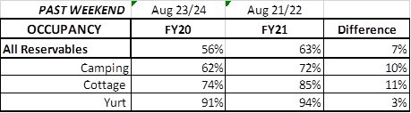

Upcoming Weekend:

For the upcoming weekend, there is a 13% decrease in all reservables at 62% occupancy. Please note that last year this weekend was the Labor Day Holiday. Camping and cottage occupancy are both trending down compared to last year, 13% and 7% respectively. Yurt occupancy is showing an increase of 16% to 95%.

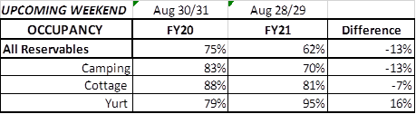

Revenue:

For FY21, July – August 23rd, park receipts have increased 8% or $425,000 due to a strong August. From the month of August, Park Receipts have increased 25% or $478K. Park Pass revenue has increased 48% or $128,000.

For this past week, August 17th – 23rd , Park Pass increased 16% or $13,000. All overnight accommodations had a significant increase for the week. Camping revenue improved 56% or $100,000. Cottage revenue increased 22% or $33,000. And Yurt revenue improved 43% or $4,000. Golf once again had a significant increase, improving 38% or $13,000.

